**AWS NLB TO LISTEN AND FORWARD TO 2 PORTS OVER TCP PASSTHROUHG**

* Go to load balancers section and choose “Create Load Balancer”
* Choose Network Load Balancer
* 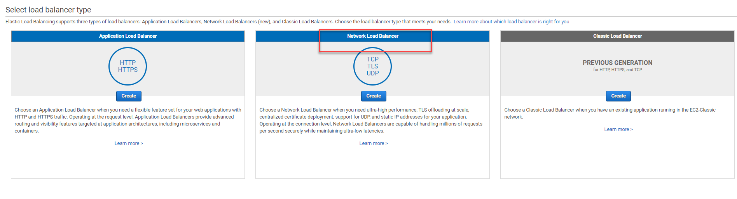
* Configure 2 the NLB and listeners as shown below and assign the right subnets which the instances to forward to are installed (use also TAG’s as needed):

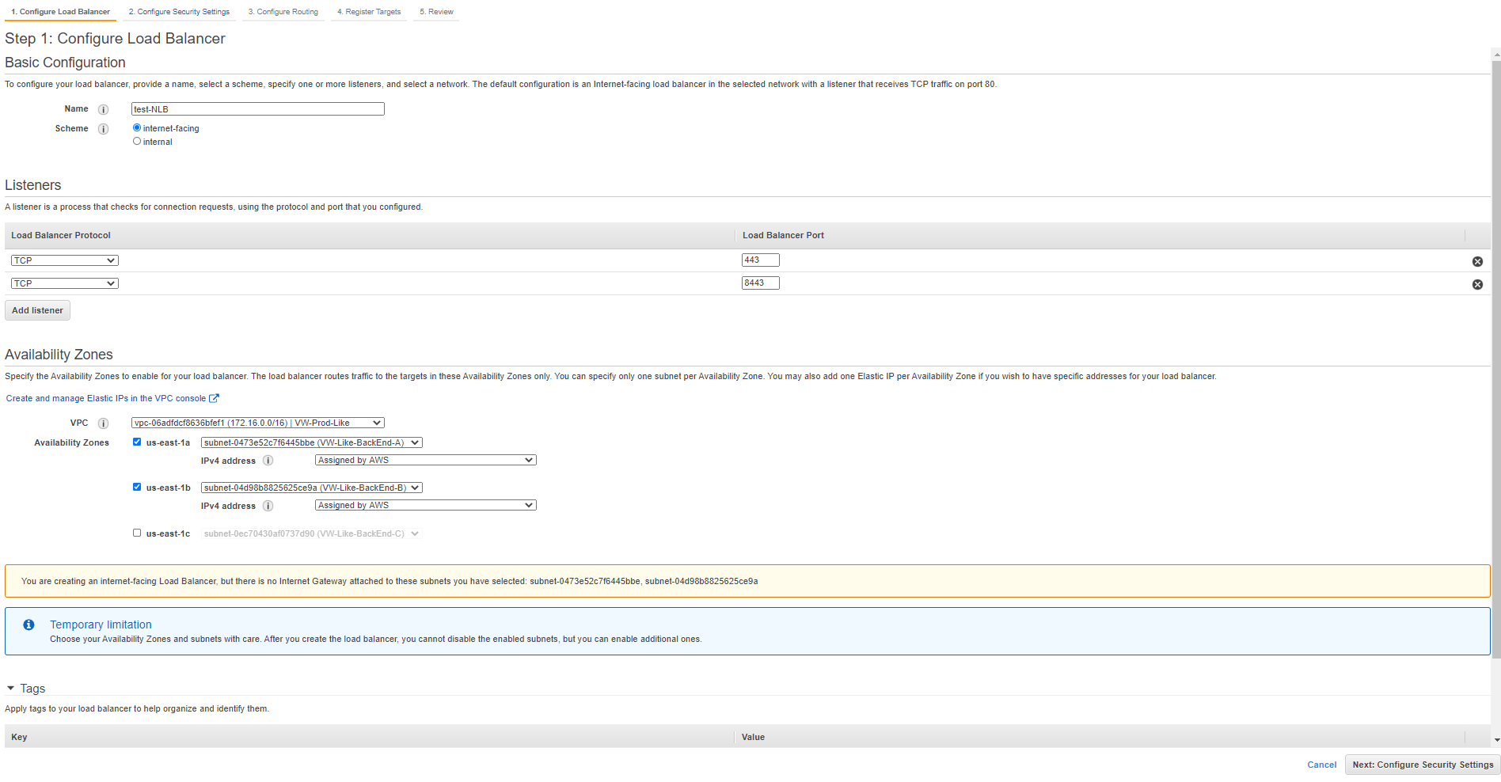

* Continue by pressing the bottom in the low corner at the right:



And then press the following button

At this section you will to configure first Target group as following:

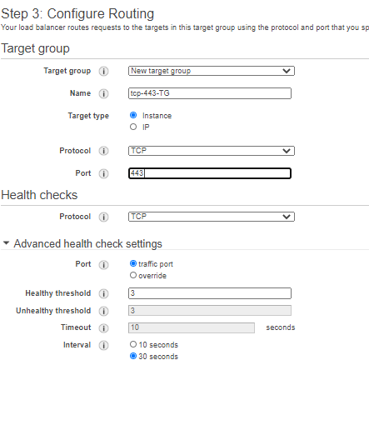

* Continue to create the Load Balancer.
* Once Load balancer is up you need to configure another Target group to match to the right listener at port **8443**:
* Go to Target groups Tab at the left and create new Target group as following (do not forget to set it to the right VPC):

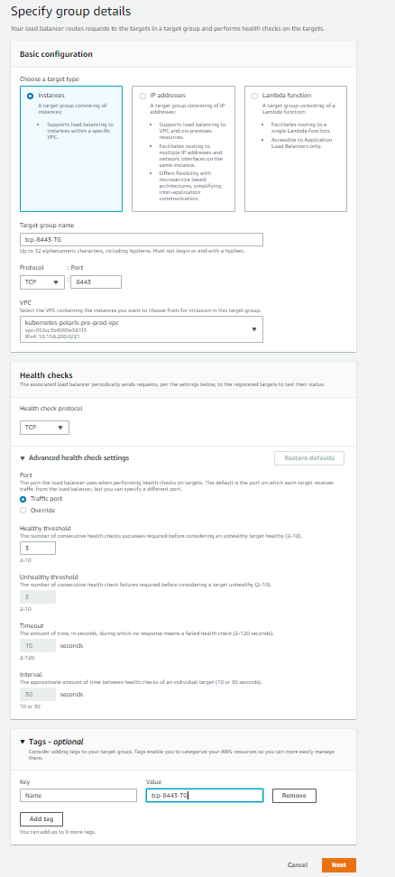

* At the next page you need to register the instances to forward requests to and create the Target Group
* Now go back to the Load Balancer that was just created and fo to the listeners Tab:

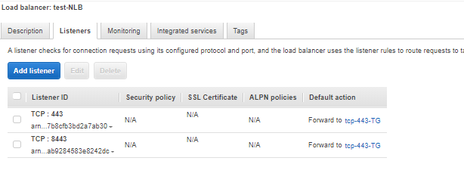

* Choose the TCP: 8443 listener and press edit and you will see the next screen:

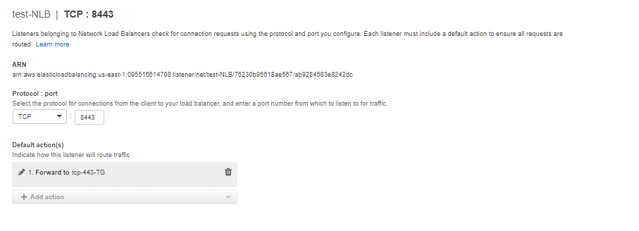

* Press on the **garbage button** to remove the default forward.
* Press “Add action” -> ”forward to” and in the Drill down choose the target group that reverse forward to 8443:

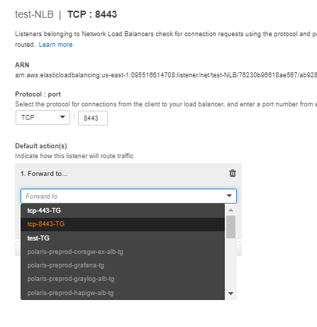

* Choose the right target group and then press the update button.